Excel Assignment 1 - Data Exploration - DOCUMENATION

1A. Formula Used: =SUM(G2:G35)
1B. Formula Used: =COUNTA(E2:E35)
1C. Formula Used: =AVERAGE(G2:G35)
2A. Formula Used: =MIN(G2:G35)
2B. Formula Used: =MAX(G2:G35)
3A. Inserted new column named “Price Range”. Then used the formula, =IF(G2>500, "High Price", "Standard Price")
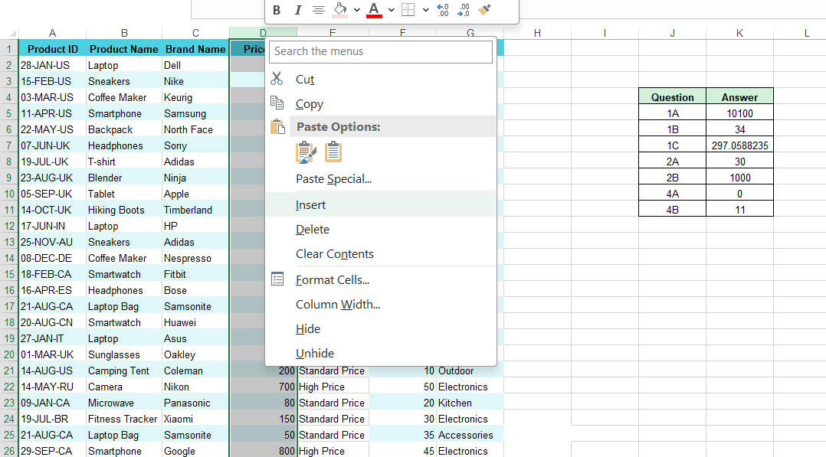

4A. Formula Used: =SUMIF(J2:J35, "Electronics", G2:G35)
4B. Formula Used: =COUNTIF(G2:G35,"<100")
5A. Inserted new column named “Day”. Then used the formula, =LEFT(A2,2)
5B. Inserted new column named “Country Code”. Then used the formula, =RIGHT(A2,2)
5C. Inserted new column named “Month”. Then used the formula, =MID(A2,4,3)

